Pictures taken during the PJJCI 29th National Convention 2004 in Cebu City

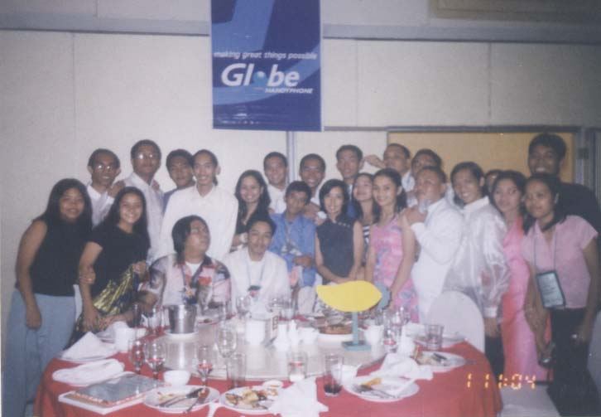
JJCs with Loly Arroyo at Grand Conventional Hotel

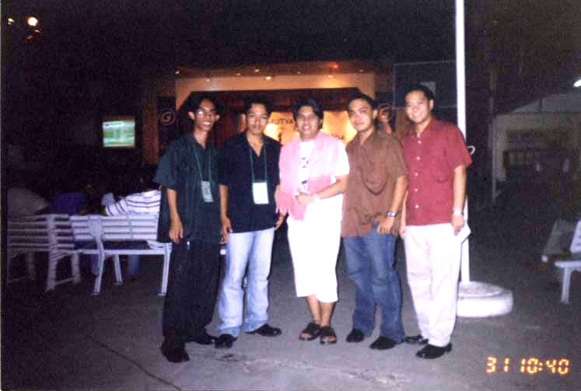
From left: JJC Bert, JJC Rumel, JJC Joel, JJC Willy and JJC Bong

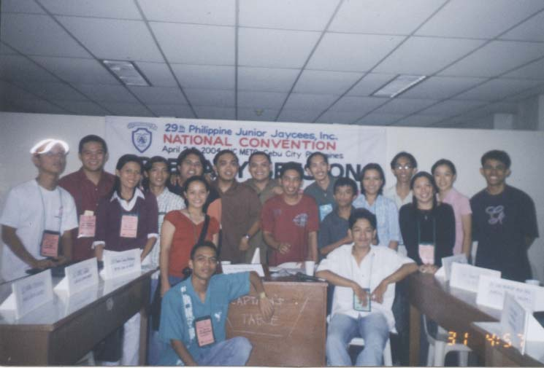
After the Plenary Session at METC-UC Mambaling, Cebu City

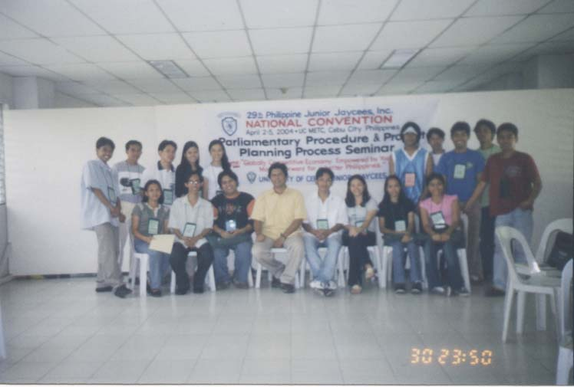
Participants to the parliamentary Procedures Seminar and Workshop with JC Russ Pascual as Resource Speaker

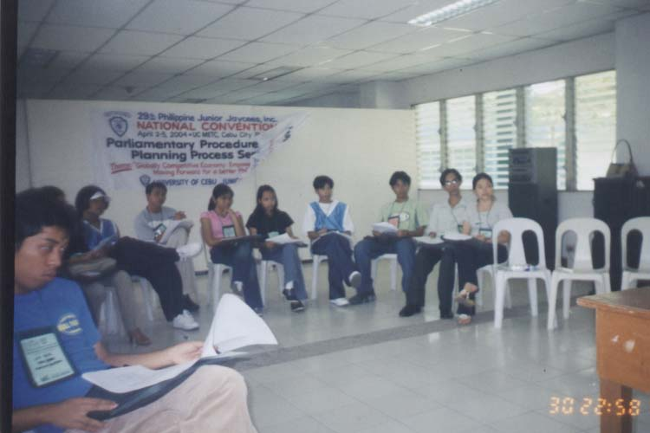
During the Parliamentary Seminar and Workshop

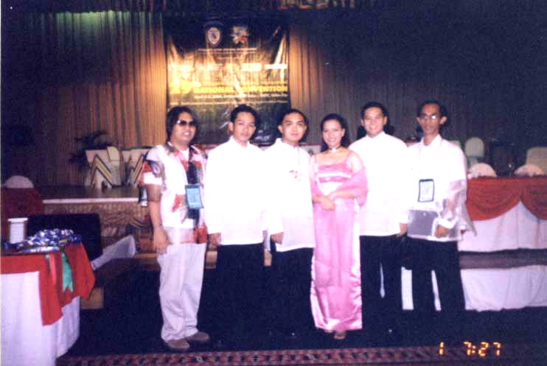
The “POSE” of the ‘National Figures’

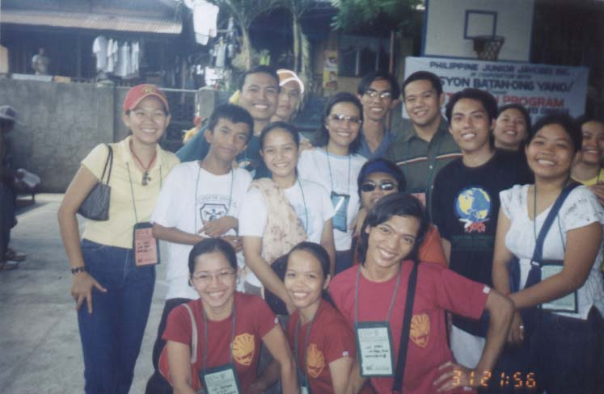
Community Outreach at Pasil, Cebu City

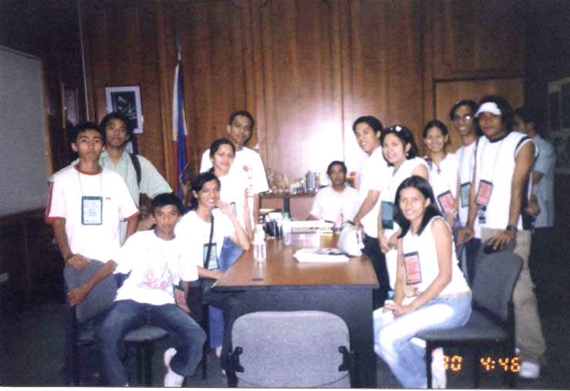
Courtesy Call before the City Vice-Mayor of Cebu City Hon. Mike Rama

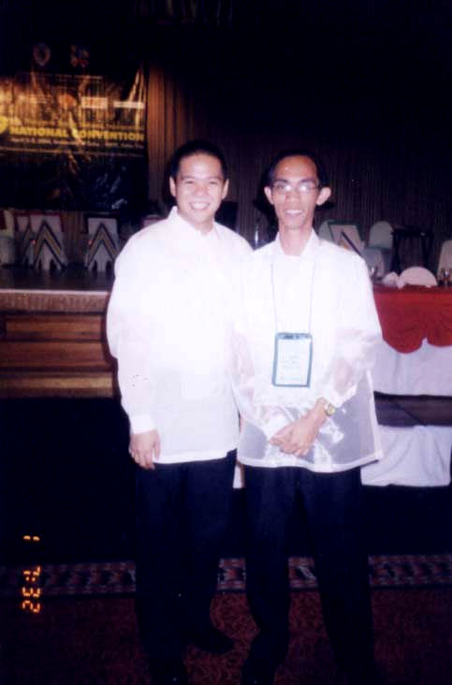
JJC Bong and JJC Bert

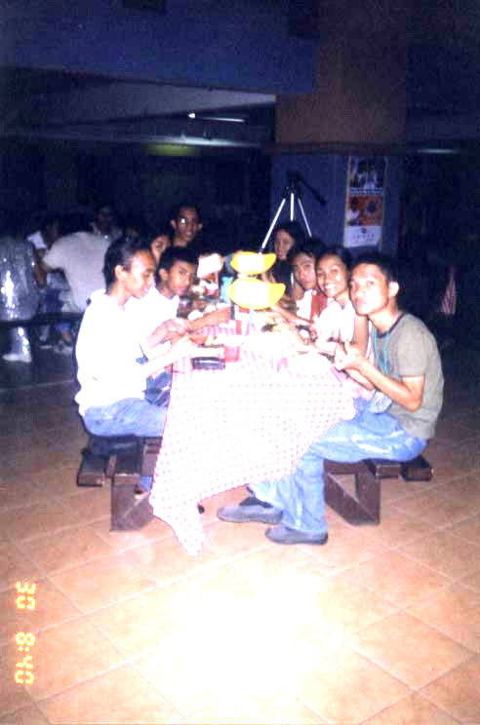

Eating time during the Grand Opening of the NatCon at the Ground Floor of University of Cebu

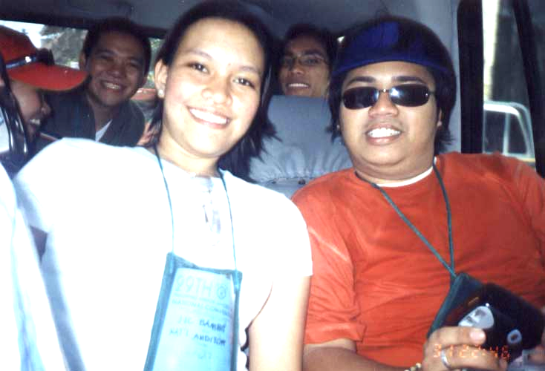
‘Escape’ of the ‘NF’ from Outreach Program to SM City!

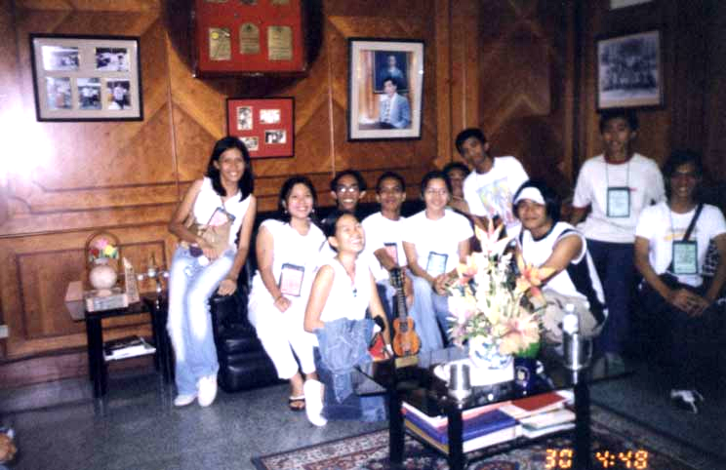
At the office of the City Vice Mayor Hon. Mike Rama

